**Day-4 session-5(16/08/2024)  
Step-1:** Connecting to the server by using   
  
 **ssh -i <private_key> ec2-user@public ip address**

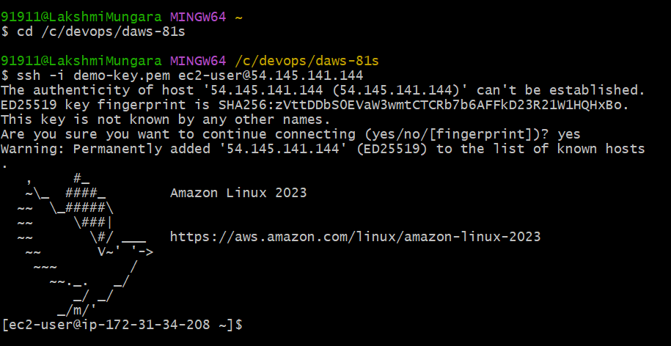

**Step-2:** Go to root server, add user and display the details

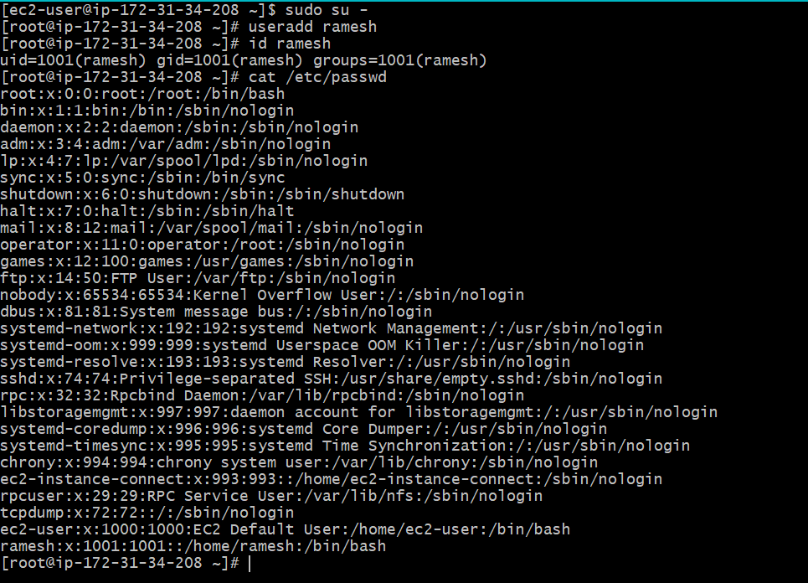

**Step-3**: create a group and display the group by using cat /etc/group

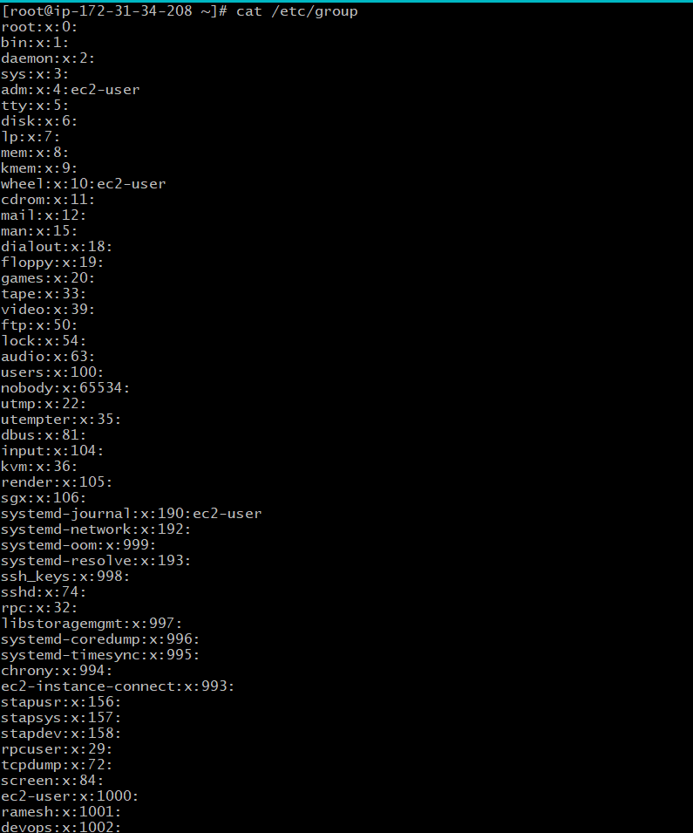

**Step-4**: Adding user to the primary group and secondary group. Give a password to the user

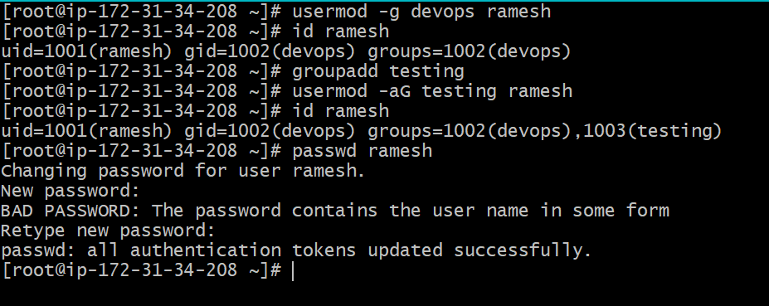

**Step-5**: Enable the passwordAuthentication yes

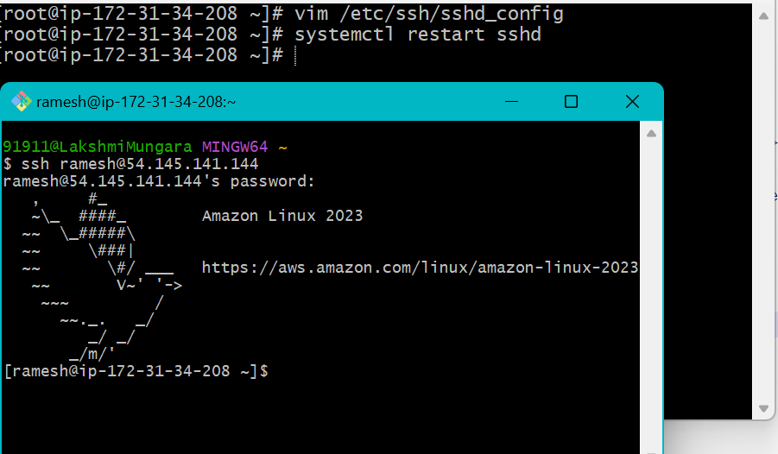

**Step-6:** Generate a key for the user called Ramesh

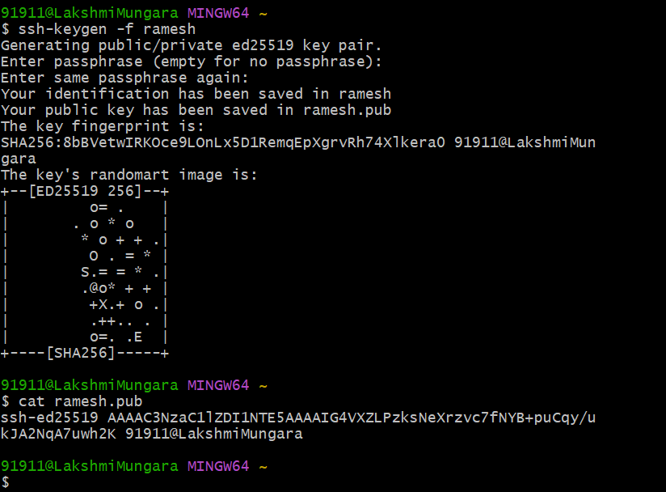

**Step-7:** Go to the user home directory

* create a folder called .ssh and give all the permissions
* create a file called authorized_keys and give –rw permissions

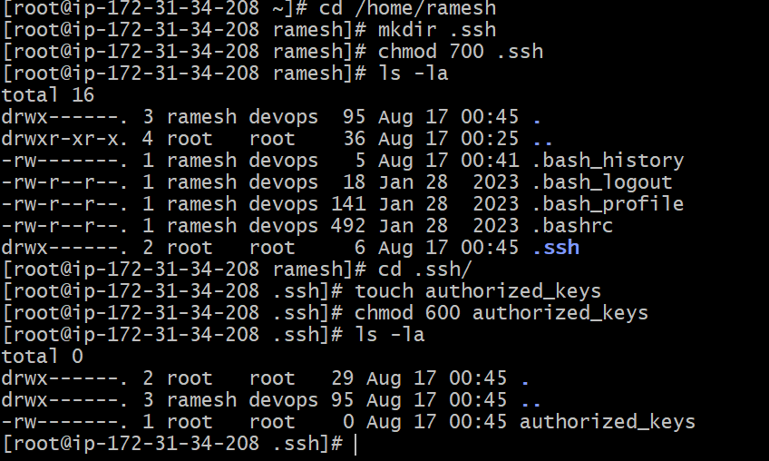

**Step-8:** Give the ownership to the user

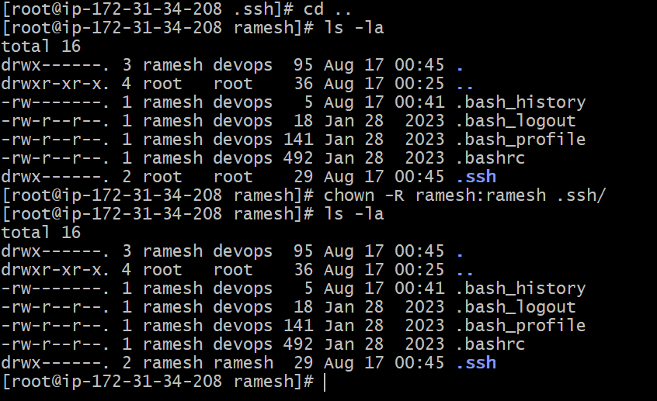

**Step-9:**  Disable the passwordAthentication no and enable the publikeyauthentication yes

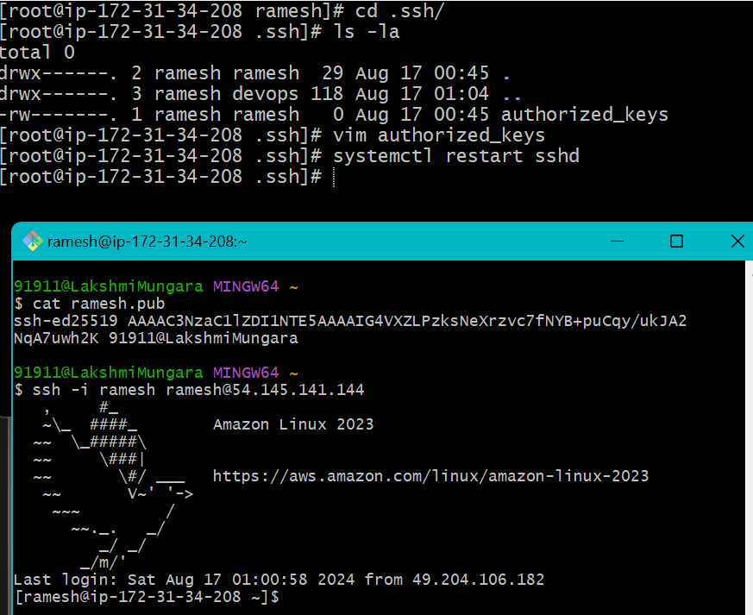

**Step-10:** Removing the user from the secondary group and deleting user

